Group 6: Nanna, Stine F.H., Bianka R., Helene and Katrine

Assignment 2

Part 1 - Basic description of language development

**- Describe your sample (n, age, gender, clinical and cognitive features of the two groups) and critically assess whether the groups (ASD and TD) are balanced**

The sample included 61 participants. 29 of these were with Autism Spectrum Disorder(ASD) with a mean age of 33 months, and 32 were typical development (TD) with a mean age of 20.4 months. Both groups consisted mainly of women.

ASD participants had a mean verbal IQ of 17.31 and TD participants had a mean verbal IQ of 20.22. Mean non-verbal IQ was 26.89 for ASD and 26.00 for TD.

**- Describe linguistic development (in terms of MLU over time) in TD and ASD children (as a function of group).**

We made the following plot showing the mean length of utterances as a function of visit number for each group**:**

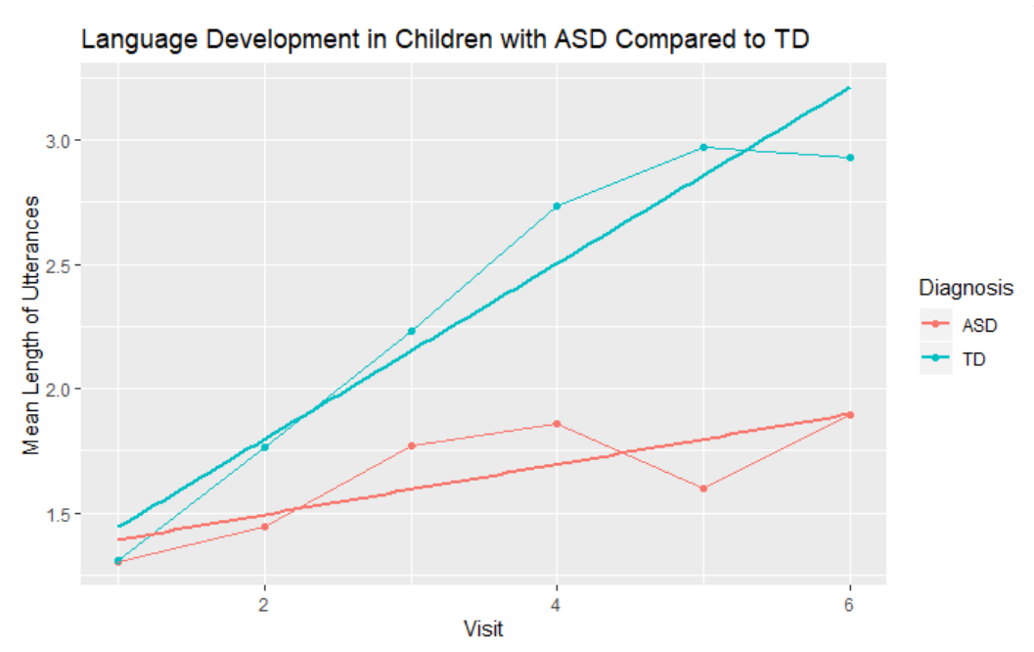

Here we see that children with ASD and TD start out with approximately the same mean length of utterances. Over time the TD children develop much faster than the ASD children.

We included a regression line as well as a line plot reflecting the mean length of utterances at each visit to clarify the development.

We make the following linear mixed-effects model:

$Mean length of utteranc{es}_{ Child}$ ~ $Visit * Diagnosis + (1+Visit|Subject)$

CHI_MLU was found to be significantly predicted by the interaction of visit and diagnosis with beta = 0.25, (SE = 0.04), t = 6.7, p < 0.01.

Linguistic development of children MLU is affected by the interaction of visit and diagnosis with random effects including random intercepts for subjects as well as by-visit random slopes for the effect of the interaction of visit and diagnosis.

**- Describe how parental use of language (in terms of MLU) changes over time. What do you think is going on?**

We made the following visualization of the data:

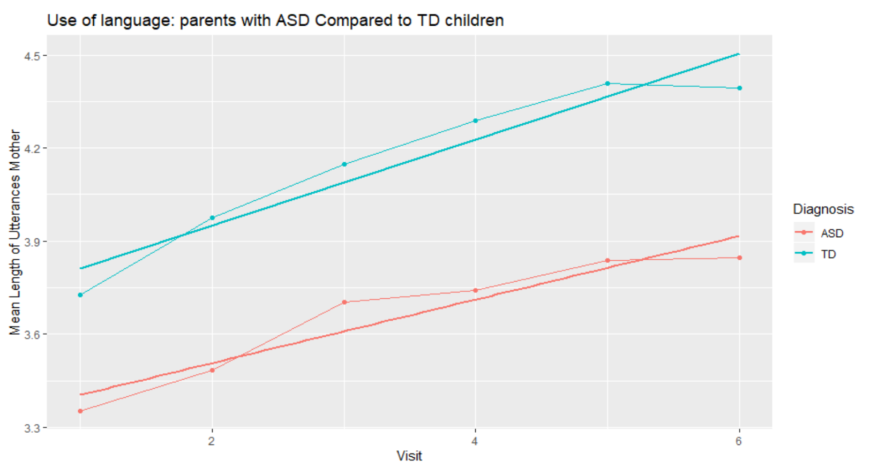

Here we see that the slopes for both parents of ASD and TD children progress similarly but differ in their intercepts. Parents of ASD children have a shorter mean length of utterances at the first visit compared to parents of TD children. But the changes over time are similar across the two groups.

Mean length utterance of parents was found to be significantly predicted by the visit and diagnosis with a significant main effects of visit with beta = 0.12., (SE = 0.02), t = 6.54, p < .01 and diagnosis beta = 0.50, (SE = 0.12), t = 4.36, p < 0.01.

Unlike the CHI_MLU there was no significant interaction effect between visit and diagnosis.

Linguistic development of the mother MLU is affected by visit and diagnosis with random effects including random intercepts for subjects as well as by-visit random slopes for the effect of the visit and diagnosis.

**- Include individual differences in your model of language development (in children). Identify the best model.**

We used the Step function, where we added all individual differences variables.

We found the best model to be:

$Mean length of utteranc{es}_{ Child}$ ~ $Visit * Diagnosis +Verbal IQ_{Visit1}+ (1+Visit|Subject)$

CHI_MLU was found to be significantly predicted by Verbal IQ from the first visit and the interaction of the visit and diagnosis with beta = 0.26., (SE = 0.04), t = 6.72, p < .01.

Assignment 2 part 2

The questions to be answered (in a separate document) are:

**1- Discuss the differences in performance of your model in training and testing data**

The RMSE in the test data is higher meaning they are worse performing than the training data.

This means there is a bigger difference between the predicted values and the actual values in the testing data. As the RMSE is twice as big in the test data, there might be an indication that we slightly overfitted the model.

**2- Which individual differences should be included in a model that maximizes your ability to explain/predict new data?**

We used the following model as the basic model:

Mean Length of Utterances for the child ~ Visit * Diagnosis + (1 + Child ID | Visit).

We added Verbal IQ to the model, which gave us a better model than the initial:

Mean Length of Utterances for the child ~ Visit * Diagnosis * VerbalIQ1 (1 + Child ID | Visit).

We measured the performances of the two models:

Mean RMSE of the basic model 0.78

Mean RMSE of the model with verbal IQ 0.56

We did find that the model had a little better RMSE when adding Ethnicity and Mother MLU, however we took into consideration that Ethnicity did not seem like a good factor, due to the fact that there might be one person from Brazil, which is rather specific, but a lot of participants who were described as “white” which is very general. Mother MLU might be correlated with child MLU.

**3- Predict a new kid's performance (Bernie) and discuss it against the expected performance of the two groups**

We found that Bernie is 0.47 below the predicted language performance measured in mean length of utterances of a typically developed child, and he is 0.17 above the predicted performance of a child with an autism spectrum disorder.

Assignment 2 part 3

**Exercise 1**

**Report the power analysis and comment on what you can (or cannot) use its estimates for.**

We created the model $Child MLU$ ~ $Diagnosis*Visit+(1+Visit|Child.ID)$

We got a power of 100% with the interaction between Visit and Diagnosis based on 50 simulations for the data’s effect size of 0.24.

With our power curve, we have more than 80% power at 9 participants.

The power is the probability of not getting a false negative given the effect size, model estimates, and the number of structured data points. The power curve we created can be used to assess how many data points are needed to have enough power in the experiment for this specific dataset, but since we have not defined a minimal interesting effect size we have not covered all the possible effect sizes below the one from our dataset.

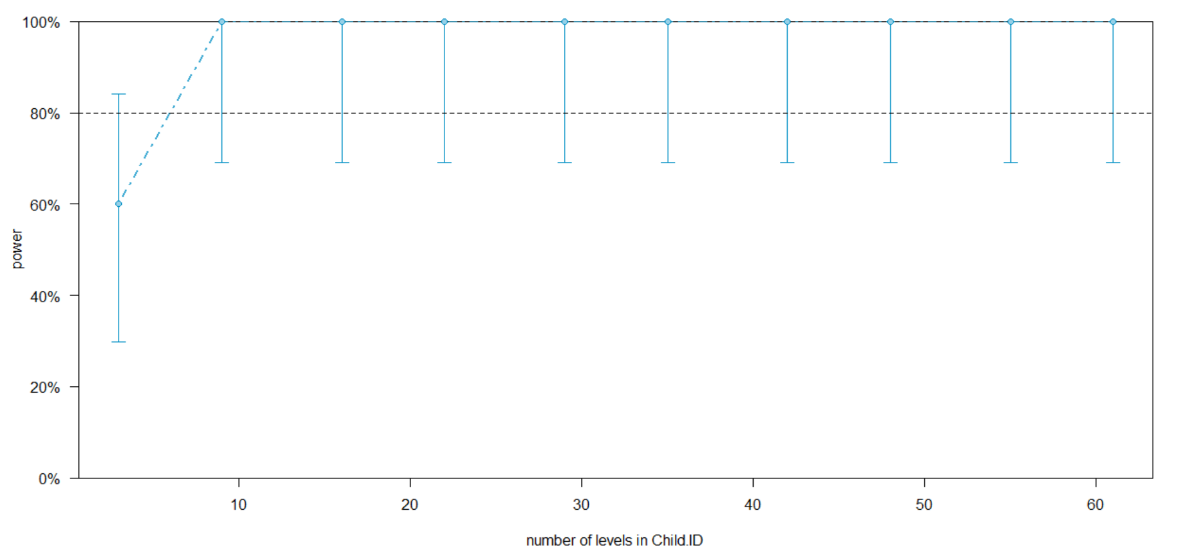

**Exercise 2**

**Report the power analysis and comment on what you can (or cannot) use its estimates for.**

We choose an effect size of 0.1, though that may seem small considering we measure in MLU we have to make it smaller than the existing 0.24 to carry out a more conservative analysis.

Here we get a power curve showing that we need at least 29 participants to get power over 80% for a minimal interesting effect of 0.1.

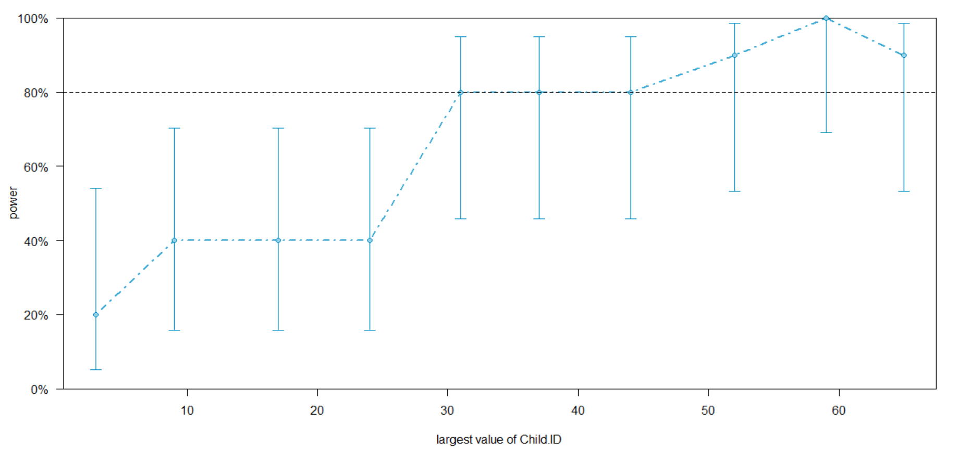

**Exercise 3**

**Assume you have only the resources to collect 30 kids (15 with ASD and 15 TDs). Identify the power for each relevant effect and discuss whether it's worth to run the study and why?**

We took a random sample consisting of 15 ASD and 15 TD kids. We chose the most relevant effect to be the interaction between visit and diagnosis. Furthermore, we set the fixed effects to a beta of 0.1. We ran the power analysis and got a power of 58.8%

Therefore it’s not worth to run the study with only 30 kids since we don’t get enough power.